Project Staker

Game Design Document

Team Weeb

Designer & Writer – Bryn Welch

Table of Contents

2 Version History 2

3 Overview 3

3.1 Vision Statement 3

3.2 Elevator Pitch 3

3.3 Core Concept 3

3.3.1 The Core Loop 3

3.3.2 Core Pillars & Player Needs 3

4 Gameplay 4

4.1 Quick Look 4

4.2 The Player Characters 5

4.2.1 Character Feel 5

4.2.2 Actions 5

4.2.3 Attributes 5

4.2.4 The Torch 5

4.2.5 Shock 5

4.2.6 Player Death 6

4.2.7 Weapons 6

4.3 Enemies - Vampires 6

4.3.1 Enemy Feel 6

4.3.2 Actions 6

4.3.3 Attributes 6

4.3.4 Bloodlust: Brief 7

4.3.5 Bloodlust: Scenario Walkthrough 7

4.3.6 Vampire Behaviour States Breakdown 8

# Version History

|  |  |  |
| --- | --- | --- |
| Version | Date | Changelog |
| 0.1 | 8/2/2017 | * Document created. * Elevator Pitch, Vision Statement & Core Concept created * Player Breakdown created * Gameplay Section created |
| 0.2 | 9/2/2017 | * Vampire States Breakdown added to Gameplay section |
|  |  |  |
|  |  |  |
|  |  |  |
|  |  |  |
|  |  |  |

# Overview

## Vision Statement

A first-person co-operative horror game focused on extreme tension and creeping dread. Mechanically builds tension by having players need to move apart to dispel enemy spawn-points before they can spawn high-danger enemies, & encourages players to rely on a torch that is very fragile as they navigate linear environments. Aimed at a $20 price point.

## Elevator Pitch

Try to survive the haunted estate of a long-dead Count with only a torch and three of your most expendable friends.

## Core Concept

Enemies do not spawn where the player/s are shedding light from torches. This causes the players to play a tense game of hide-n-seek with semi-randomly instantiating enemy spawners in their local area as they progress through linear levels, splitting them up and slowing their progress, and building creeping tension.

### The Core Loop

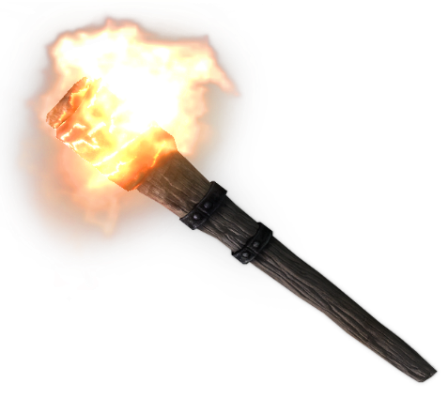

The three stage core loop of the game leans on the player torch mechanic; When holding a torch, the players can move up to a spawning vampire and burn away the darkness before the creature is fully formed and capable of attacking them.

### Core Pillars & Player Needs

The game builds itself off two core pillars:

* **Fear** of the unknown, in the oppressive and dangerous game environment,
* **Relief** or release of tension, as player success brings brief respite from the horrors of the game, and
* **Social** satisfaction, as the experience is intended to be most rewarding when playing with friends.

The player/s should be experiencing varying levels of low-level anxiety as they progress through the game, getting pangs of genuine fear.

# Gameplay

## Quick Look

The gameplay of Project Staker relies on two core systems:

* The **Light Generation** system, and the system it interacts with,
* **The Smokespawn** system.

The way these systems work is fairly simple: A player holding a lit torch can, as they progress through game levels, prevent dangerous enemies from spawning by finding their spawn location, marked by gathering black smoke (A particle effect), and shedding light on this smoke. This light is shed in a 270-degree radius, being blocked by the player’s own body as they hold out the torch.

This mechanic gives the players the need to essentially manage spot fires – dangerous, vampiric spot fires – or become overwhelmed. The first layer of gameplay this mechanic gives is essentially a deadly game of hide-and-seek.

The second layer of gameplay comes when the vampires actually spawn; Although they are not damaged by the light, they find it unpleasant. After a vampire spawns and starts to chase a player, that vampire will be unwilling to enter the light for a short amount of time, giving a period to the player where they are directly threatened without being damaged.

Finally, the vampire will begin to outright attack them. It can be dissuaded by players responding, but in this stage, the best chance for the players is to mount a fighting retreat to any safe place they can see – Houses with barricadable doors, or the hallowed ground of a church.

Although the players can become empowered by finding weapons such as silver swords and blessed crossbows, these weapons do not kill their enemies, merely dissuading the beasts from continued attack for a time.

At the outset of the narrative, the players’ goal is to kill Count Lugos, the Sire of the brood infesting the Lugos Estate. Mechanically, however, the goal of the players is to find places of rest. These places – high hills, abandoned churches, old gatehouses – serve as the breakpoint between levels, and lead them ever closer to the Mansion.

To complicate the players’ journey from safety to safety, level obstacles that will cause one or more player to drop their torch – Such as a gate that must be cranked open – Will be used to ratchet up the tension, forcing the players to wait agonizing seconds as the hissing in the dark grows louder.

## The Player Characters

### Character Feel

The player characters are contrasted against the fast, dauntless and nigh-invulnerable vampires; They are slow, tire easily, and die even easier.

### Actions

The players can take these actions:

* **Move**, via WASD controls.
* **Sprint,** via left shift.
* **Jump,** via spacebar.
* **Kick**, via the K button.
* **Wave Torch**, via the left mouse button when holding a torch. Initially reduces vampire bloodlust and extends the light radius.
* **Attack,** via the left mouse button when holding a weapon.
* **Light Torch,** via the E button when holding a torch & near a light source.

### Attributes

The players have these attributes:

* **Health**, in the form of a three-hit-down system. When struck three times in succession, players will go into a ‘Shock’ state where they are vulnerable to being killed by a vampire. These three health points recharge at a rate of 1/30s. A player brought back from Shock has 1 hit point. Player screens greyscale as they lose health, making it harder to see.
* **Stamina**, another recharging resource utilized for sprinting (left shift) and attacking. If the player is out of stamina, they cannot sprint or attack. Stamina will recharge after not being used for several seconds.
* **Light Radius**, a stat determined by whether the player is holding a lit torch or not.

### The Torch

The player’s primary line of defense and the core mechanic of the game, the torch sheds light in a 270-degree radius around the player. This ring of light burns away the smoke that the vampires come from, and the vampires are hesitant to enter the ring of light – They must reach a threshold in their Bloodlust stat to do so.

When wielding the Torch, a player can left-click to wave the torch in front of them. This will decrease the Bloodlust level of vampires.

### Shock

When a player reaches zero hp, they go into Shock. Their screen goes black, and their character falls over, but they can still hear. Their torch goes out.

Another player can shake a player out of Shock in five seconds by pressing the E button. Otherwise, they will get up by themselves in 30 seconds.

When in Shock, any attack made by a vampire on a player will cause a vampire to Feed, killing the player instantly and setting the vampire’s Bloodlust to 100.

### Player Death

When a player ‘dies’, their body will ragdoll. The player’s corpse is transported to designated points later in the level. Should the rest of the players reach one of these points, they can shake the ‘dead’ player awake.

### Weapons

Throughout the environment, the players can find weapons. When wielding these weapons, the player’s torch is doused and put away.

There are two variants of weapon: **Sword** and **Crossbow.**

#### The Sword

The player can swing the sword with left click. This will cause them to consume stamina and damage any enemies in front of them in a wide arc.

#### The Crossbow

The player can press left click to fire a crossbow bolt. This will not consume stamina, but after firing, the crossbow must be reloaded and this will consume stamina. The player can choose to reload by pressing R.

## Player Light Generation

When holding a lit torch, the player casts light around themselves in a radius. Although this makes their immediate area brighter, it actually makes it harder for them to see, as the moonlight also quite bright.

Vampires approaching a player with a lit torch will hover at the edge and stalk them as they build up their Bloodlust.

When the player swings their torch, it briefly increases the radius of light around them, causing stalking vampires to back up.

## Enemies – Vampire Smokespawn System

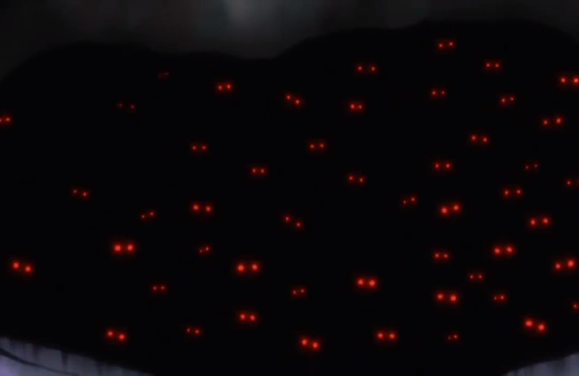The Smokespawn system is the way in which the vampires are brought into world-space. A mass of shifting black shadows resembling smoke begins to form in the dark wherever a player is not looking, and there is a hideous sucking sound. Glowing red eyes begin to show in the smoke, and after a short amount of time determined by game level, a single vampire steps out of the smoke, which then dissipates.

Using the Light Generation system, the player can burn away these smokespawns before the vampire steps out.

## Enemies – Vampire Breakdown

### Enemy Feel

The vampires are extremely dangerous, being fast, vicious and nigh-unkillable.

### Actions

The vampires can perform these actions, which are active in certain states,

* **Move**, pathing to the player or through the environment,
* **Stalk**, hovering at the player’s light radius,
* **Attack**, swinging at the player,
* **Feed**, on a player in Shock, killing them, and
* **Flee**, when their Bloodlust reaches zero.

### Attributes

The vampire has these attributes:

* **Scent Range,** an adjustable radius from the vampire which will be used to simulate smell. When utilizing Scent, the vampire will not auto-face the players.
* **Sight Range**, an adjustable radius from the vampire used to simulate sight. When a target is in sight range, the vampire will always face the closest target.
* **Stalk Range**, a distance from the player that the vampire will stay while in the Stalk state.
* **Bloodlust**, it’s primary behavior determinant. Bloodlust is a very complicated statistic, and explained in greater detail in its own section below.
* **Hatred**, a secondary behavior determinant. When the vampire is in the **Attack** state and has its **Bloodlust** reduced by a player, it will build the **Hatred** stat against that player. If a vampire’s **Hatred** for a player is above a threshold, it will preferentially target that player instead of the closest target.

### Bloodlust: Brief

The vampire has one core attribute that is used to determine their behavior – Bloodlust. Rather than dying when their Bloodlust hits zero, the enemy will simply flee and, given enough distance between the players and the creature, disappear into smoke.

The Bloodlust stat will guide the vampire through several key behavior states dependent on the Bloodlust count. These states are **Explore, Stalk, Attack,** and **Flee,** and they flow together naturally. Let’s walk through an example.

### Bloodlust: Scenario Walkthrough

See Vampire States flowchart.

A vampire has spawned outside of immediate aggression range (which is a variable set depending on the specific level the vampire is placed in,) of the players with a **Bloodlust** count of 20. As it has just spawned, the vampire is in the **Explore** state. It wanders in the general direction of the players, but not directly at one of them until it comes into Scent Range of the players.

Once inside this aggression range, the **Bloodlust** count of the vampire begins to tick up rapidly. Once it hits **the Stalk Value**, the vampire enters the **Stalk** state and begins to path directly towards the players. During **Stalk**, the vampire’s **Bloodlust** begins to tick up, and it hovers at the edge of player’s light radius as they are holding a lit torch. Once it hits the **Attack Value**, the vampire enters **Attack.**  One player waves their torch at the vampire, reducing the vampire’s **Bloodlust** count, and pushes the vampire back into the **Stalk** behavior state for a few moments. But not for long.

Important to note is that a vampire will not exit the **Stalk** state unless it triggers the requirements to enter **Attack** or **Flee**. In other words, once a vampire begins stalking its prey, it will not stop unless the players are dead, they drive it away, or they get outside of its Scent Range.

So the vampire has entered **Attack.** It ignores the light and begins to attack relentlessly. The one player with a sword attacks the vampire, setting the **Bloodlust** count down by his weapon damage value each strike. The vampire’s **Bloodlust** count is set to back below the **Attack Value** – the vampire re-enters **Stalk**, retreating to the edge of the light.

The player with the sword moves in to continue attacking the vampire, but the overconfident swordsman leaves the ring of light. The close range and lack of light sets the vampire’s **Bloodlust** to the **Attack Value** threshold automatically, and the vampire strikes.

Before the vampire is scared off, it hits the player holding the sword and sends them into Shock. This does not actually raise its bloodlust; it’s still at the precipice of running away. But the players, scared, move away from their fallen comrade, and he falls outside the circle of light.

The vampire then enters a sub-state of **Attack**: **Feed.** With the fallen player separated, the vampire leans down and bites onto the neck, killing the player instantly.

After **Feeding**, the vampire’s **Bloodlust** is set to maximum. However, the other players have managed to reach safety; They’ve ran into a church as the vampire fed. The vampire enters **Flee** and disappears in a puff of smoke after pathing away from the players for a few seconds.

### Vampire Behaviour States Breakdown

#### Explore

The vampire spawns in this state. It moves randomly in the general direction of the players until one enters its scent range. It has a static Bloodlust count until a player is within scent or sight range.

#### Stalk

The vampire enters this state when within scent or sight range of a player, and its Bloodlust count has exceeded the Stalk threshold. The vampire paths to the edge of a player light radius, if it has one, and begins to increment Bloodlust.

#### Attack

The vampire ignores player light radius and attacks. If a player has a Hatred value exceeding threshold while the vampire is in this state, it will pursue and target that player. Otherwise, it will target the closest player.

If a player is put into Shock while the player is in Attack, and that player does not have another player holding a torch over them, the vampire will Feed, killing the shocked player instantly.

#### Flee

If a player with a sword attacks the vampire enough times and puts its Bloodlust count below the Flee threshold, or the vampire cannot path to living players, the vampire will Flee. The vampire will path in the opposite direction of the players if it can, or otherwise path randomly, then de-spawn.

### Vampire Hatred

The Hatred stat is a simple numerical variable that increments every time a player strikes an individual vampire, and decrements over time. Once the Hatred for a player is in excess of a threshold, and the vampire is in an attack or stalk state, the vampire will target that player.

## Level Obstacles

Although level obstacles may come in different aesthetic varieties, their core principle is simple: They remove one player from the team lineup for a finite amount of time while they complete a task.

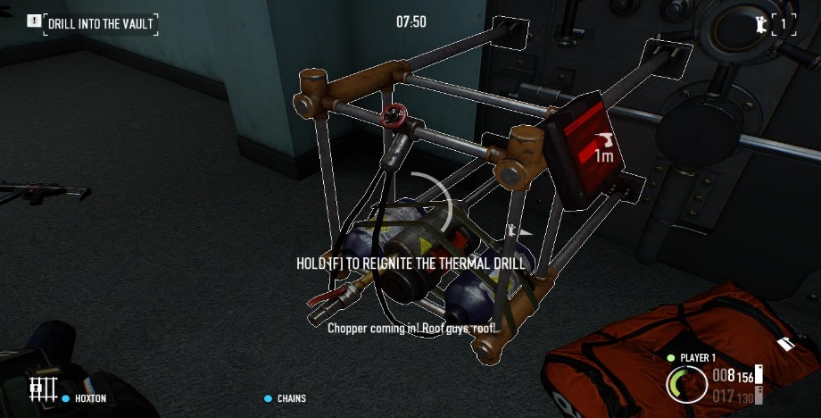

*A screencap from Payday 2 wherein a player is reigniting a thermal drill by holding down the F key and standing still. This is mechanically very similar to our goal; The player is removed from the action, and reliant on his teammates to protect him.*

The intent of these tasks is to raise tension: The players are forced to be stationary in a single area while the task is completed.

Here’s an example for Staker: 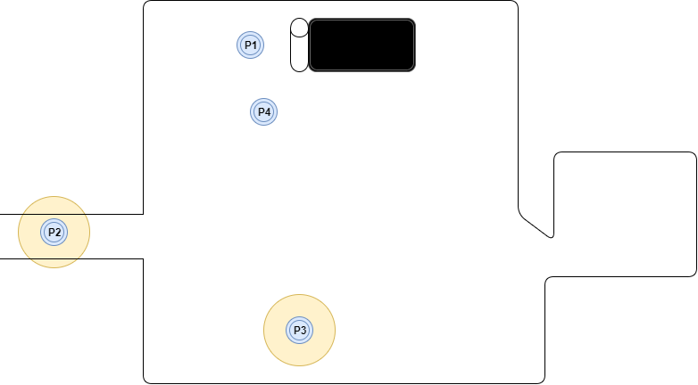

This group is in the Crypt, and have to winch up the elevator from the lower levels to access the next level.

Player 1 is winching up the elevator, which means he has to put his torch out and down.

This leaves only Player 2 and Player 3 with torches. Player 2 and 3 are patrolling, trying to keep on top of Smokespawns, but they can’t cover everything; They’ve left the antechamber unattended. Tension is high, as it’s only a matter of time before a vampire spawns in there, but leaving the main room unattended would be even more disastrous – Something could spawn in there and start attacking the unlit group members immediately.

If these players stack up and try to huddle in the light, they will be overrun with vampires. But if they split too far, they risk one spawning behind their backs. Tension is high.

# Target Market & Competitor Analysis

## Target Market Breakdown

Our game:

* Co-operative Multiplayer with no matchmaking,
* Has an expected 1 - 2 hour session length,
* Is in the survival horror genre, and
* Is for PC with a price point of $20 & planned release on Steam.

Although survival horror falls into the bottom 4.1% ‘All Other’ category of the NPD Group/Retail Tracking Service’s 2016 list of best-selling super genres, there are some caveats that work in favor of our game.

The first and foremost is that this is an underserved genre with a dedicated buying fanbase; Resident Evil and Silent Hill are enduring franchises in the single-player horror genre on consoles, and in the co-op multiplayer market, Valve’s Left 4 Dead and Left 4 Dead 2 are games with enduring popularity and persistent userbases 8 years after the release of the second game. Just this year, IllFonic’s Friday the 13th has sold 1.8 million copies at a $40 USD price point. There is more on some of these games in the competitor analysis, but there is clearly a market for survival horror games.

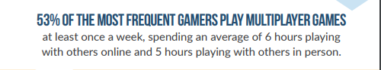

*Images taken from the ESA’s 2017 Essential Facts document.*

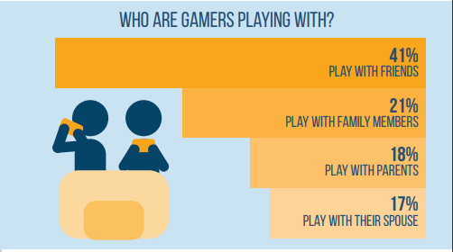With this in mind, we can draw several conclusions about our target market from the breakdown of our game. Our core audience:

* Have a social network to play with,
* Have a fair-to-large amount of free time,
* Enjoy horror games, and
* Have moderate disposable income.

Although there is no available solid data on horror *games* and their average age range, according to 2015 Nielsen Fanlinks data, horror *movie* fans are 25% more likely to be between 35-44. They are also 23% more likely to be Hispanic, or 15% more likely to be African-American.

Important to note is that based on Steam Spy creator Sergey Galyonkin’s 2015 [datamine of Steam](https://galyonk.in/some-things-you-should-know-about-steam-5eaffcf33218), 51% of Steam frontpage visitors are Male, 4% are Female, and the remaining 45% are unknown. This data is not 100% accurate, but it does display a trend.

Based on these statistics, we can isolate a core audience: Male gamers fitting the 27-38 age bracket, of middle-class economic status, with a social network. This perfectly suits the average age of gamer, and the right age to target players of our nearly ten-year-old competitors Left 4 Dead 1 & 2.

Of course, gamers of any gender aged 18-26 form a viable secondary market; The game does not have particularly male-focused elements.

## User Profiles

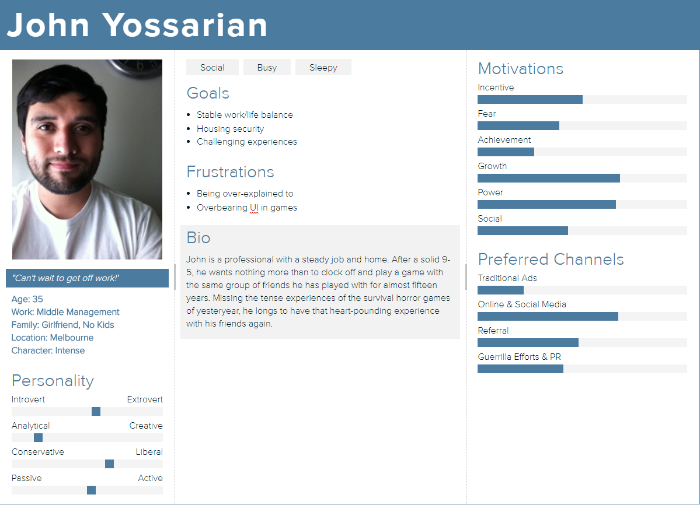

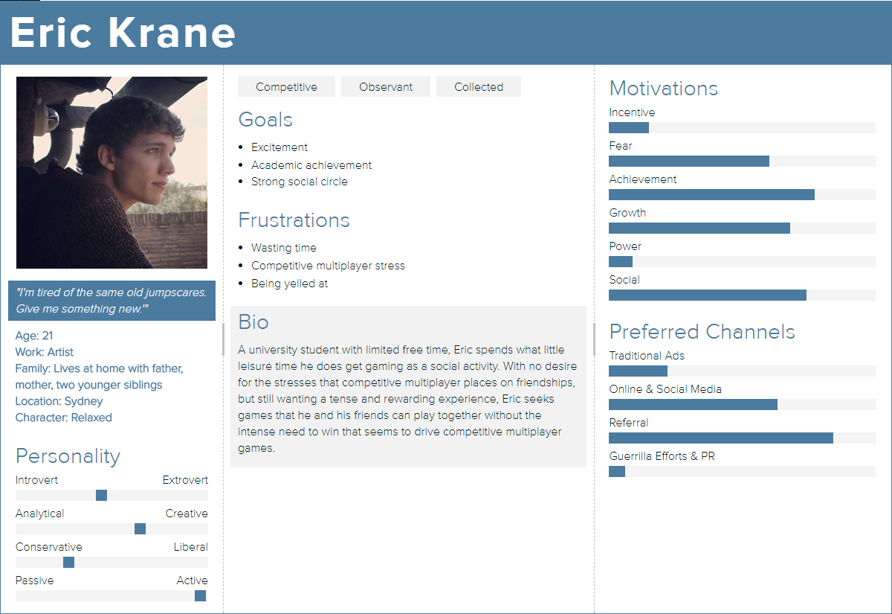

## Competitor Analysis

### http://cdn.akamai.steamstatic.com/steam/apps/550/header.jpgLeft 4 Dead & Left 4 Dead 2

Pulling in over 20 million total owners between them, the 8-year-old Left 4 Dead series still retains some 500,000 active players. A classic of the survival horror genre & focused on a similar style of multiplayer, it provides stiff competition on the quality barrier, being produced by Valve as a triple A production compared to our own indie team. However:

* Updated engines in the current time allow us to approach graphical parity with a much smaller team.
* It has been 6 years since the last major content update to L4D2. The persistent player interest in the game is shown through it’s still-active modding community; They clearly desire more.
* Our game fills a different aesthetic genre (Victorian era Vampire tale vs. Modern American zombie shooter) & focuses more on the horror and disempowerment aspects of the survival horror genre, differentiating ourselves significantly.

The Left 4 Dead series could potentially serve as a source of pre-installed users, as all of its PC players will be integrated with Steam and we are selling at a familiar price point.

### Image result for amnesia dark descentAmnesia – The Dark Descent

Frictional Games’ Amnesia was released as an independent game in 2010 and over its lifespan has won two IGF awards, earned critical acclaim and certainly turned a profit with an estimated 1.4 million sales by September 2012 at a $20 USD price point. If nothing else, Amnesia shows that there is a market for horror games, and indie horror games at that.

In our favor or points of differentiation from Amnesia are the facts that it:

* Was released 7 years ago.
* Is not a co-operative experience.
* Has a short total playtime.
* Has a different aesthetic.
* Focuses entirely on horror and disempowering the player.
* Released at the same $20 price point we’re aiming for.

### SOMA

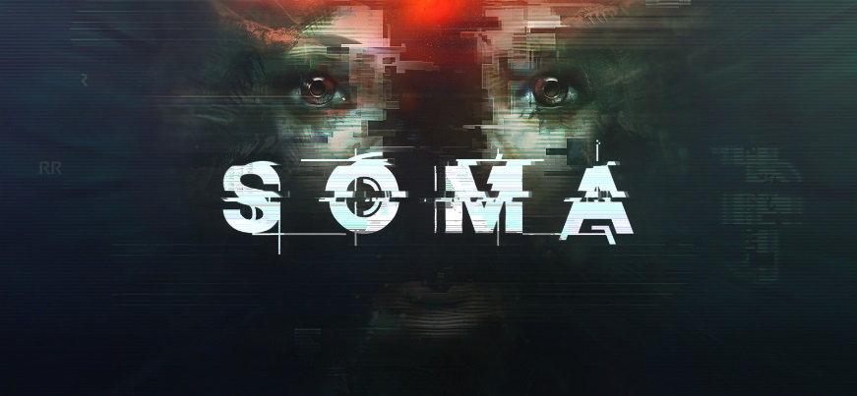Frictional Games’ SOMA, a sci-fi horror game released in September 2015, sold 450,000 copies by November 2016, marking another successful entry in the horror genre for Frictional.

* Not a co-operative experience.
* Very different aesthetic.
* Focuses entirely on horror and disempowers the player.
* More expensive than what we aim to release at, at a $30 price point.

## Unique Selling Points

In comparison to these games, we can define our USPs as:

* A co-operative horror game focused on **high tension**.
* To our knowledge this specific combination of aesthetic and genre has not been delivered on in games as of yet.

This positions us nicely in the market to take advantage of a classic genre that is underserved in games, but maintains consistent popularity in the film market – At least one film a year for the last century has had vampires as a major theme.

## Streaming & Community Content as Advertising

Something worth noting is that in the current atmosphere of the games industry, sales and customers are no longer solely influenced by press outlets & word of mouth. The cottage industry of Let’s Plays & streaming is a significant force that can influence the total sales of a game.

Of games that get the Let’s Play treatment, Horror is one of the most prevalent genres and one that has a historical record of garnering sales from people streaming their content. Five Nights At Freddies, an indie horror title, was a hit with both Let’s Players and their fans alike, and the game saw a marked uptake in sales after it made the rounds on these games.

In the realm of streaming but outside the horror genre, recent battle royale shooter Playerunknown’s Battlegrounds made a big splash on streaming website twitch.tv, starting a strong upswell of player interest.

Our game is positioned to take advantage of all of these circumstances – Including PUBG’s recent success – due to its blend of horror themes and co-operative gameplay.

If we deliver on the intended experience, the game will make for good viewing material; What polls best with Let’s Play fans is watching the Let’s Player have some sort of emotional reaction, especially a fear reaction.

And with PUBG’s rising success, there are many streamers pulling upwards of 20-30k viewers nightly that have a pre-gathered group of 4 players that are willing to play games publicly as entertainment, and dedicated viewers that we can expose our game to.

Targeting these streamers is a potential strategy, and one that stands to be cheaper than traditional advertising – If the game proves popular with their viewers, many of them will essentially advertise the game for free.

# Production

## Milestones

### Alpha – 11th Aug to 1st September

* Basic modelled player character for all 4 players that can:
  + Move in 3D space (Animated)
  + Follows mouse direction when looking
  + Pick up the torch
  + Light the torch (Animated)
  + Swing the torch and influence the enemy AI (Animated)
  + Pick up the sword
  + Swing the sword and deal damage (Animated)
  + Take damage from the enemy
* Basic modelled enemy that can:
  + Move in 3D space (Animated)
  + Displays a functional version of the AI states outlined in the Enemy – Vampires section
  + Attack the player (Animated)
* Basic enemy spawner that:
  + Is animated via functional particle effect
  + Spawns an enemy after a timer
  + Is destroyed by torch light or after an enemy spawns
* Tutorial and 1st Level including:
  + Modelled, untextured assets for:
    - Buildings (Outdoor & Indoor)
    - Lantern posts
    - Trees
    - Key level features (Tutorial Level Bridge, 1st Level Church)
  + Scripted interactions including:
    - Openable/closable doors
    - Lighting torch off lantern posts
* Audio for:
  + Vampire walk cycle
  + Vampire attack
  + Torch swing
  + Sword swing
  + Player takes damage
  + Player death
  + Player walk cycle
  + Lit Torch crackle
* Start Menu with LAN networking host/connection capabilities

### Beta – 1st September to 13th Oct

Feature complete stage:

* Modelled & textured player characters that can:
  + Pick up the Torch (animated)
  + Pick up the Sword (animated)
  + Interact with Level Obstacles (animated)
  + Respawn at later
* Modelled & textured vampire enemies that:
  + Display a polished version of each of the states listed in the Enemy – Vampires section
  + Disappear in a puff of smoke when the Flee state ends
* Polished enemy spawner that:
  + Plays a particle effect when destroyed.
  + Plays an audio effect when destroyed.
* Tutorial, 1st and 2nd level including:
  + Textured and polished assets.
  + Level Obstacles.
  + Level transition triggers/level completion
* Main menu

### Gold - 13th Oct to 1st December

Polish stage:

* Player character:
  + Hit stagger
  + Hit feedback
* Vampire:
  + Blood particle effect on hit
  + State change animation feedback
  + State change audio
* Audio for:
  + Ambient sound
  + Miscellaneous SFX - Doors etc
  + Vampire hiss
  + Vampire scream
* In-game exit/settings menu
* Polished & iterated Tutorial, 1st and 2nd level.

## Testing Plan

We will be employing multiple testing strategies throughout development, but our primary means of testing will be Internal due to time cost of other methods.

### Alpha

* **Concierge Testing** – Beer n Pixels is an excellent location to get dev-friendly outside eyes on a project, and test the tutorialization, readability and onboarding of the core mechanic in quick sessions with successive people.
* **Internal Testing** – During block and downtime, testing is something that every player can do. Team members that are not normally hands-on familiarizing themselves with the game also has benefits and cements the core vision within the team.
* **Functionality Testing** – At this early stage, this is simply a necessity.

### Beta

* **Internal Testing** – As the game further approaches feature completion, the workload of the designer and artists shift slightly, and there is a bit more room for internal testing.
* **Regression Testing** – Bugfixing from the alpha stage should be in effect at this point, and trying to replicate them in later revisions should begin at the start of Beta.
* **Closed Beta/Questionnaire Testing** – With the game getting closer to feature completion, we can gather data on whether our mechanics are working as intended, as well as aesthetic & setting.
* **Stress Testing** – The more that goes into the game, the more risks we run of memory leaks. This strategy is too resource intensive in Alpha, but in Beta having a computer locked into long-term stress testing is not the end of the world.
* **Beta Testing** – We should have the levels complete by the latter half of Beta, which is a perfect time to give the game to players and let them break it by themselves.

### Gold

* **Internal Testing.**
* **Analytics Testing** – At this point we should have compiled enough data from Questionnaire and Concierge testing to calculate average playtime on levels, player engagement, and other useful statistics. Here we can get a hint at any major flaws that have slipped in under the radar.
* **Beta Testing** - Will still continue up til a week before release.

## Budget

* $ 11k AUD employee pay.
* $12k Licensing Fees – Maya, Unity Pro
* $11K Marketing Costs
* $10K Contingency
* $8K Legal Fees/Screen Australia

Total Amount Requested: $52K.